Git Branching

- Branching means you diverge from the main line of development and continue to do work without messing with that main line.

- A branch in Git is simply a lightweight movable pointer to one of these commits

- Git branches is incredibly lightweight, making branching operations nearly instantaneous, and switching back and forth between branches generally just as fast.

Commit Overview

When you make a commit, Git stores a commit object that contains a pointer to the snapshot of the content you staged. This object also contains the author’s name and email address, the message that you typed, and pointers to the commit or commits that directly came before this commit (its parent or parents): zero parents for the initial commit, one parent for a normal commit, and multiple parents for a commit that results from a merge of two or more branches.

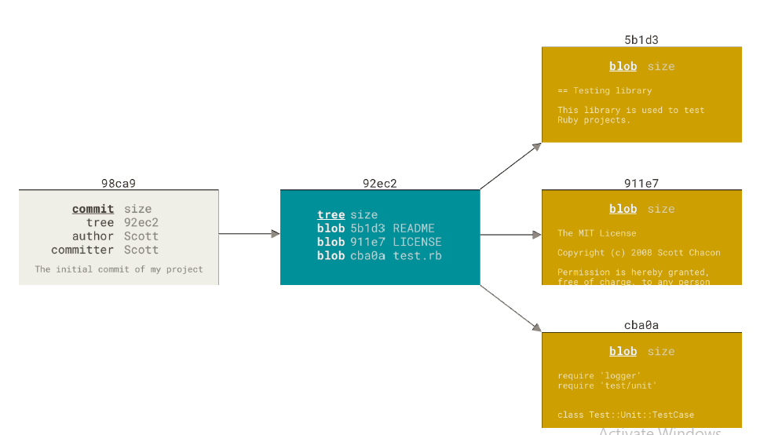

- To visualize this, let’s assume that you have a directory containing three files, and you stage them all and commit. Staging the files computes a checksum for each one (the SHA-1 hash we mentioned in Getting Started), stores that version of the file in the Git repository (Git refers to them as blobs),
and adds that checksum to the staging area:

- When you create the commit by running git commit, Git checksums each subdirectory (in this case, just the root project directory) and stores them as a tree object in the Git repository.

- Git then creates a commit object that has the metadata and a pointer to the root project tree so it can re-create that snapshot when needed.

- Your Git repository now contains five objects: three blobs (each representing the contents of one of the three files), one tree that lists the contents of the directory and specifies which file names are stored as which blobs, and one commit with the pointer to that root tree and all the commit metadata.

If you make some changes and commit again, the next commit stores a pointer to the commit that came immediately before it.

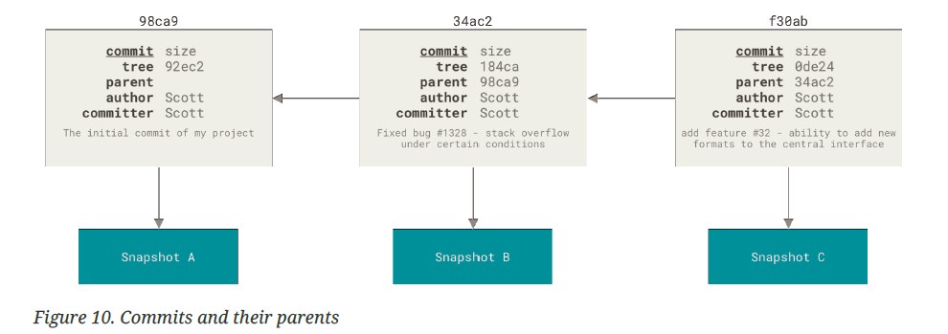

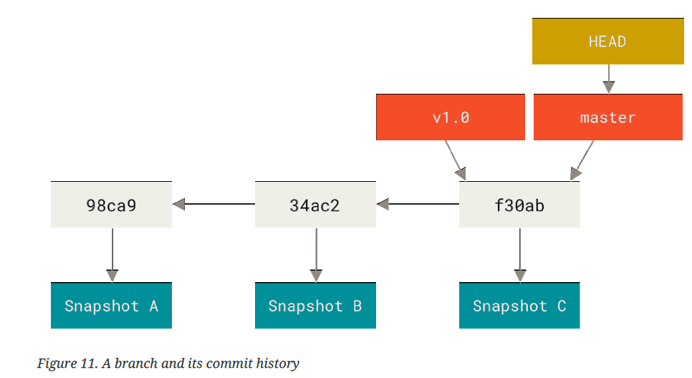

Creating New Branch

- $ git branch <branch name>

- What happens when you create a new branch? Well, doing so creates a new pointer for you to move around.

- HEAD points to the current branch
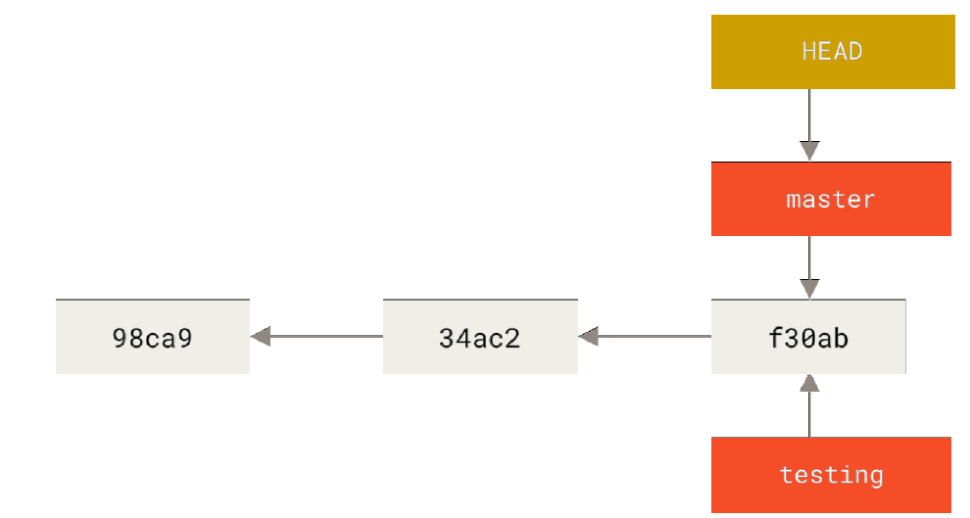

Switching Branches

$ git checkout <branch name>

This moves HEAD to point to the testing branch

If u commit any files here Figure 15. The HEAD branch moves forward when a commit is made.

HEAD moves when you checkout

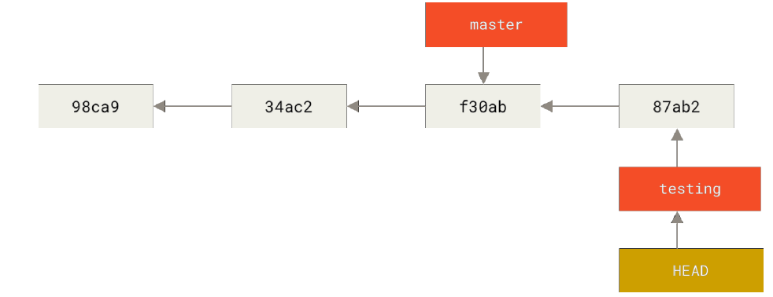
Switching branches changes files in your working directory

It’s important to note that when you switch branches in Git, files in your working
directory will change. If you switch to an older branch, your working directory
will be reverted to look like it did the last time you committed on that branch. If Git cannot do it cleanly, it will not let you switch at all.

Divergent History

$ git log --oneline --decorate --graph –all

This is in sharp contrast to the way most older VCS tools branch, which involves copying all of the project’s files into a second directory. This can take several seconds or even minutes, depending on the size of the project, whereas in Git the process is always instantaneous

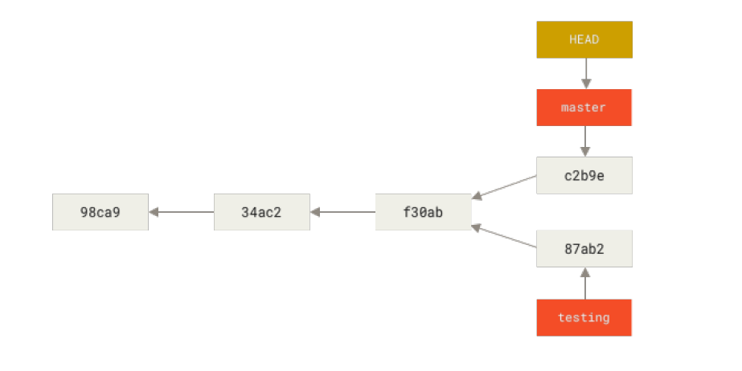
Creating a new branch and switching to it at the same time

- git checkout –b <newbranchname>

Basic Branching and Merging

- Let’s go through a simple example of branching and merging with a workflow that you might use in the real world. You’ll follow these steps:
- Do some work on a website.
- Create a branch for a new user story you’re working on.
- Do some work in that branch.

At this stage, you’ll receive a call that another issue is critical and you need a hotfix. You’ll do the following:

- Switch to your production branch.
- Create a branch to add the hotfix.
- After it’s tested, merge the hotfix branch, and push to production.
- Switch back to your original user story and continue working.

If your working directory or staging area has uncommitted changes that conflict with the branch you’re checking out, Git won’t let you switch branches.

It’s best to have a clean working state when you switch branches. There are ways to get around this (namely, stashing and commit amending)

Merging

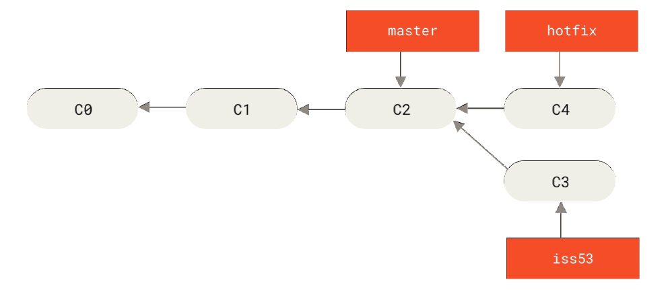

Merging hotfix to master

$ git checkout master
$ git merge hotfix

fast-forward merging because when you try to merge one commit with a commit
that can be reached by following the first commit’s history, Git simplifies things by moving the pointer forward because there is no divergent work to merge together — this is called a “fastforward.”

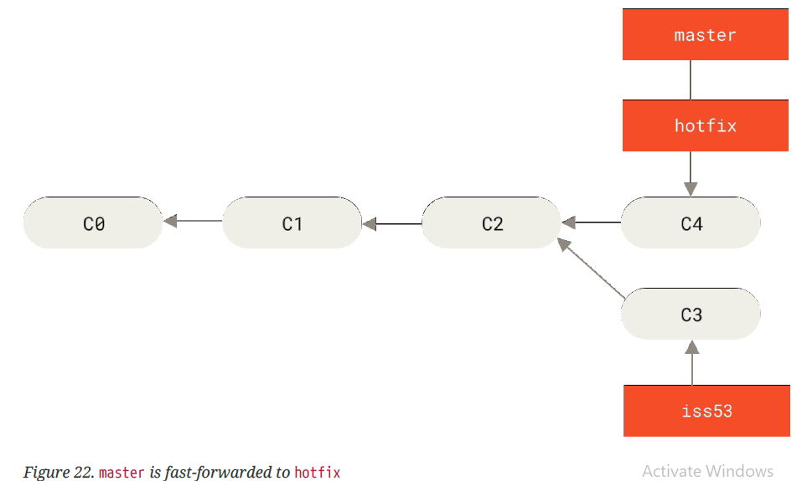

3 WAY MERGING

Issue53 into master

your development history has diverged from some older point. Because the commit on the branch you’re on isn’t a direct ancestor of the branch you’re merging in, Git has to do some work.

In this case, Git does a simple three-way merge, using the two snapshots pointed to by the branch tips and the common ancestor of the two.

C2 is the common ancestor

Post 3 way merge

Instead of just moving the branch pointer forward, Git creates a new snapshot that results from this three-way merge and automatically creates a new commit that points to it. This is referred to as a merge commit, and is special in that it has more than one parent.

Basic Merge Conflicts

If you changed the same part of the same file differently in the two branches you’re merging, Git won’t be able to merge them cleanly.

Anything that has merge conflicts and hasn’t been resolved is listed as unmerged

$ git mergetool

Branch Management

- $ git branch [listing of your current branches]

- $git branch –v [To see the last commit on each branch]

- $ git branch --merged
[To see which branches are already merged into the branch you’re on]

- $ git branch --no-merged
[To see which branches are not merged into the branch you’re on]

Delete the branch

- $ git branch -d hotfix

- $ git branch -D hotfix [force delete]

Branching Workflows

Figure 26. A linear view of progressive-stability branching

Many Git developers have a workflow that embraces this approach, such as having only code that is entirely stable in their master branch — possibly only code that has been or will be released.

They have another parallel branch named develop or next that they work from or use to test stability — it isn’t necessarily always stable, but whenever it gets to a stable state, it can be merged into master

It’s used to pull in topic branches (short-lived branches, like your earlier iss53 branch) when they’re ready, to make sure they pass all the tests and don’t introduce bugs

Remote Branches

Remote references are references (pointers) in your remote repositories, including branches, tags.

$ git remote

$git remote show <remote name>

Once you cloned and merged remote repo iinto your local repo, then remote branch appeared as origin/master where local branch refered as master.

To synchronize your work with a given remote, you run a git fetch <remote> command (in our case, git fetch origin). This command looks up which server “origin” is (in this case, it’s git.ourcompany.com), fetches any data from it that you don’t yet have, and updates your local database, moving your origin/master pointer to its new, more up-to-date position

Pushing

When you want to share a branch with the world, you need to push it up to a remote to which you have write access.

Your local branches aren’t automatically synchronized to the remotes you write
to — you have to explicitly push the branches you want to share.

If you have a branch named serverfix that you want to work on with others, you can push it up the same way you pushed your first branch. Run

$ git push <remote> <branch>

If you didn’t want it to be called serverfix on the remote, you could instead run git push origin serverfix:awesomebranch to push your local serverfix branch to the awesomebranch branch on the remote project.

If you don’t want to type it every single time you push, you can set up a “credential cache”. The simplest is just to keep it in memory for a few minutes, which you can easily set up by running git config --global credential.helper cache.

FETCH

$ git fetch origin

$ git merge origin/master

Tracking Branches

Tracking branches are local branches that have a direct relationship to a remote branch. If you’re on a tracking branch and type git pull, Git automatically knows which server to fetch from and which branch to merge in.

When you clone a repository, it generally automatically creates a master branch that tracks origin/master.

However, you can set up other tracking branches if you wish — ones that track
branches on other remotes, or don’t track the master branch.

$ git checkout --track origin/serverfix

To set up a local branch with a different name than the remote branch, you can easily use the first version with a different local branch name

$ git checkout -b sf origin/serverfix

If you already have a local branch and want to set it to a remote branch you just pulled down, or want to change the upstream branch you’re tracking, you can use the -u or --set-upstream-to option to git branch to explicitly set it at any time.

$ git branch -u origin/serverfix

If you want to see what tracking branches you have set up, you can use the -vv option to git branch.

$ git branch –vv

If you want totally up to date ahead and behind numbers, you’ll need to fetch from
all your remotes right before running this. You could do that like this:

$ git fetch --all; git branch –vv

Pulling

While the git fetch command will fetch all the changes on the server that you don’t have yet, it will not modify your working directory at all. It will simply get the data for you and let you merge it yourself.

However, there is a command called git pull which is essentially a git fetch immediately followed by a git merge in most cases

Deleting Remote Branches

$ git push origin --delete serverfix

Rebasing

In Git, there are two main ways to integrate changes from one branch into another: the merge and the rebase.

rebase has powerful history rewriting features

Rebasing is the process of moving or combining a sequence of commits to a new base commit.
From a content perspective, rebasing is changing the base of your branch from one commit to another making it appear as if you'd created your branch from a different commit. t's very important to understand that even though the branch looks the same, it's composed of entirely new commits.

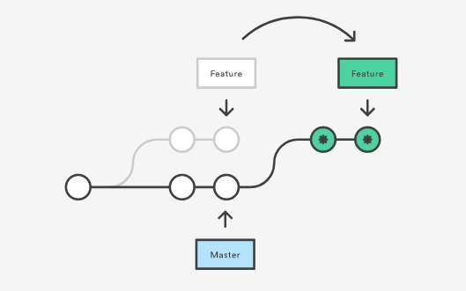

git checkout feature
git rebase master

This moves the entire feature branch to begin on the tip of the master branch, effectively incorporating all of the new commits in master. But, instead of using a merge commit, rebasing re-writes the project history by creating brand new commits for each commit in the original branch.

After Rebase

This operation works by going to the common ancestor of the two branches (the one you’re on and the one you’re rebasing onto), getting the diff introduced by each commit of the branch you’re on, saving those diffs to temporary files, resetting the current branch to the same commit as the branch you are rebasing onto, and finally applying each change in turn.

At this point, you can go back to the master branch and do a fast-forward merge.

$ git checkout master
$ git merge experiment

If you examine the log of a rebased branch, it looks like a linear history: it
appears that all the work happened in series, even when it originally happened in parallel.

More Interesting Rebases

You can also have your rebase replay on something other than the rebase target branch.

Suppose you decide that you want to merge your client-side changes into your mainline for a release, but you want to hold off on the server-side changes until it’s tested further. You can take the changes on client that aren’t on server (C8 and C9) and replay them on your master branch by using the --onto option of git rebase:
$ git rebase --onto master server client

This basically says, “Take the client branch, figure out the patches since it diverged from the server branch, and replay these patches in the client branch as if it was based directly off the master branch instead.” It’s a bit complex, but the result is pretty cool.

$ git checkout master
$ git merge client

When Not To Rebase

The golden rule of rebasing is to not rebase public branches. The rebase would replace the old commits with new ones and it would look like that part of your project history abruptly vanished.

In general the way to get the best of both worlds is to rebase local changes you’ve made but haven’t shared yet before you push them in order to clean up your story, but never rebase anything you’ve pushed somewhere.

Usage

The major benefit of rebasing is that you get a much cleaner project history.

